**COSC 310 Chatbot Project**

**Team Members:**

Allan Tsai

Brett Dupree

Manny Haller

Mike Nowicki

**Instructor:**

Dr. Bowen Hui

**Description of the Project:**

Develop an interactive conversational travel agent that responds to user questions using Java. The user can ask the chatbot any question that is related to the trip such as weather of the destination, cost of the vacation, and transportation for the trip, etc.

Repository URL: <https://github.com/allantsai123/COSC310project>

**SDLC: Scrum combined with Incremental**

We choose scrum combine with incremental because we can separate the whole project into small tasks (divide and conquer approach), and each member can work on one part of the project. We also want to prioritize the tasks so we know which functions need to be implemented as soon as possible. Since there will be lots of rapidly changing during the design and development phase, we want to have lots of testing and meetings so we can exchange ideas, update the status and address the issues.

**SDLC Phases:**

1. Planning and Design Phase
   1. Set up the GitHub
      1. Repository and project file set up
      2. Learn push, pull, branch
   2. To know and learn what the project is and how to implement it.
      1. Find some example of Chabot.
      2. Figure out what type of Chabot we are making.
   3. Discuss how to separate the project into different tasks
      1. Functionalities/Sizing
      2. DB? API?
      3. Determine who is doing which task.
2. Development and Testing Phase
   1. Code implementation
      1. Each member code on their own time.
   2. Merging the code
      1. Combine the code from each member
      2. Understanding the code from other
   3. Testing the code
      1. Unit tests
      2. Fixing the code
3. Documentation and Maintenance Phase
   1. Document how the project work in a detail way
      1. Explaining how each method, function, or class works.
      2. List of limitations
   2. More functions?
      1. Discuss the time left and implement more features?

**WBS in Table Form:**

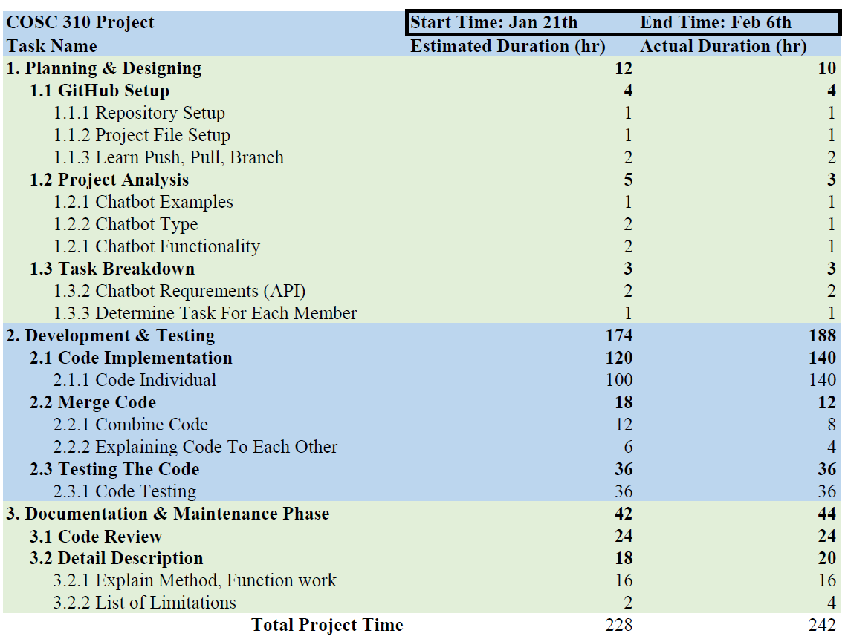

**WBS in Tree Graph:**

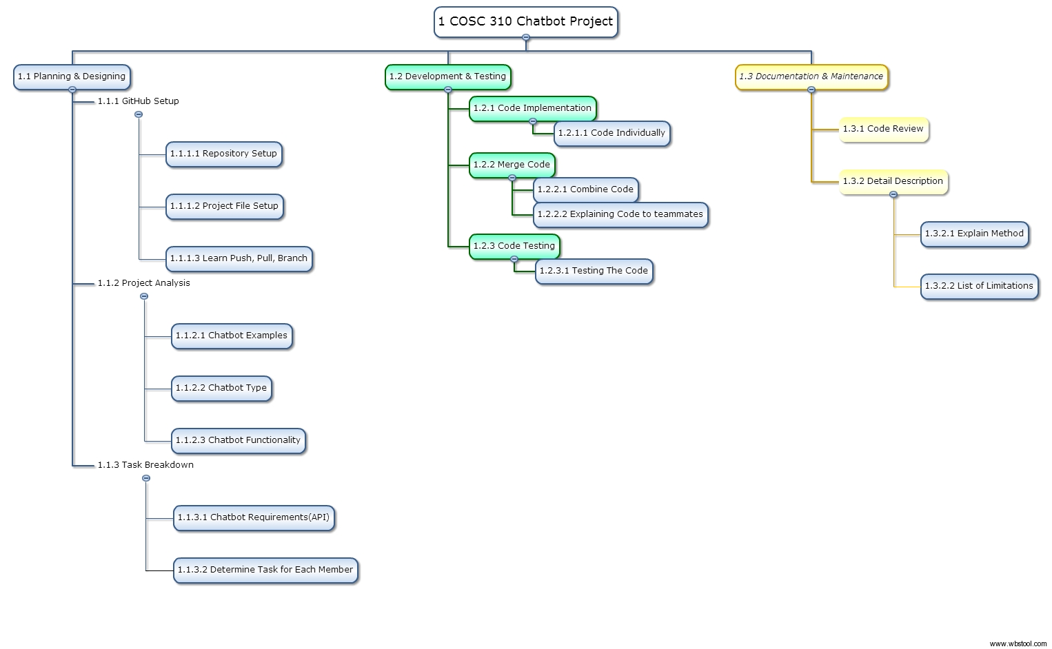

We choose Democratic Team Approach for team organization, where everyone takes a part of the project and work on their own. We use this strategy because each teammate has the same role and it is much more productive than other approaches. This method also let us practices egoless programming, where we are less likely to criticize each other (make decisions by consensus) and more motivation to find errors which improve our project.

In Planning and Designing phase, we estimate 12 hours of working time. However we spent 10 hours on this phase, which is pretty close to our estimated time.

In phase 2, Development and Testing, our WBS chart shows that we spent most of the time in this phase, and we end up have to spend more time on code implementation. Our actual time on merging the code is less than the estimate time is because we utilized the pull and push function in GitHub.

In Documentation and Maintenance phase, our actual time is very close to the estimated time. And we spend a little more time on the documenting the methods, and functions.

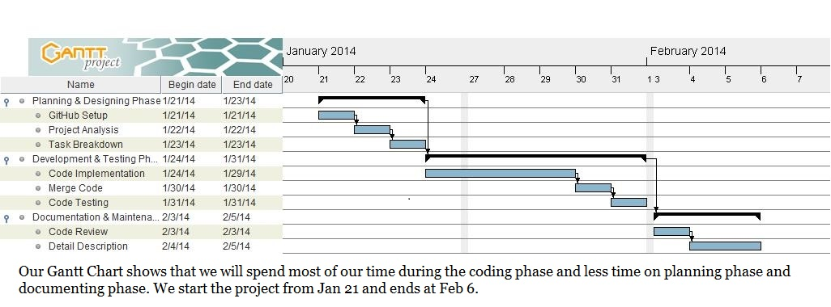

**Gantt Chart:**

**Actual Timeline:**

**Project Starts:** Jan 21th

**Project Ends:** Feb 7th

**Project starts:**

**Phase 1:**

Jan 21th: Discuss on how to deal with assignment 2 after class

Jan 22th: Set up the GitHub repository and add project folder

Jan 25th: Research on the topic

Jan 27th: Meet at the library; discuss the topic and what functions should be implemented. (basic structure of the code)

**Phase 2:**

Jan 28-31th: Implement the code individually.

Jan 29th: Meet at the library; discuss and revise the code

Jan 31-Feb 3rd: finish up the coding part of the project.

**Phase 3:**

Feb 3rd: Meet at the library; discuss what is done and what is left.

Feb 4th: Documentation.

Feb 5-7th: Meet at the library; finishing up the project. (Presentation)

**Sample Conversation:**

TravelBot started at Feb 06, 2014 12:06:41 PM

Powered by Google

Travel Bot: Hi, how can I help?

User: I'd like to go to Mexico

Travel Bot: Mexico is very nice! Where would you like to go in Mexico?

User: Cancun.

Travel Bot: Everybody loves Cancun, Mexico!

User: Can I drive there?

Travel Bot: You can if you want to. Driving to Cancun, Mexico, from Kelowna, BC would cost approximately $3119.0.

User: Ok, can I fly then?

Travel Bot: Calculating... Yes, we have two direct flights to Cancun and numerous other flights that leave daily.

User: How far is it to Cancun

Travel Bot: The distance between Kelowna, BC and Cancun is 6300.37 kilometers.

User: what can I do in cancun?

Travel Bot: Cancun, Mexico is a wonderful place!

User: what activities are in Cancun

Travel Bot: While you are there you could enjoy the beach and tan, or you could explore the local wildlife areas

User: how far is it from Cancun to Chichen Itza

Travel Bot: The distance between Cancun and Chichen Itza is 200.21 kilometers.

User: How can I get around?

Travel Bot: You should be able to walk to most places within the city. Otherwise coach buses are a good way to get around the country.

User: Can I go on a cruise there?

Travel Bot: Well let me find out... Sure, we are partnered with many different cruise lines.

User: can you find me a hotel?

Travel Bot: Sorry, I don't understand what you said.

User: I want to book a hotel

Travel Bot: Were you interested in a family resort, or one of our luxury offerings?

User: I can afford $80 a night

Travel Bot: Searching for the best accomodations that match you budget. Our top discount hotels in Cancun are Hotel Plaza and Hotel Tropicoco. Only $55 a night.

User: Can I cancel my reservation?

Travel Bot: Were you interested in a family resort, or one of our luxury offerings?

User: Where can I eat?

Travel Bot: Calculating... It's all about street vendors and local food there.

User: I want to go soon, what's the weather like?

Travel Bot: It is currently 28.55 degrees C in Cancun

User: is there anything else I should know?

Travel Bot: Sorry, I don't understand what you said.

User: Thanks

Travel Bot: No problem.

User: What other cities are around Cancun.

Travel Bot: Well, the biggest are , Mexico City, Tijuana, Juarez, Cancun, Mexicali, Chihuahua.

User: maybe i'll go to mexico city

Travel Bot: Mexico City, Mexico is a wonderful place!

User: how far is cancun from mexico city

Travel Bot: The distance between Mexico City and Cancun is 1604.3 kilometers.

User: do i need a passport?

Travel Bot: Were you interested in a family resort, or one of our luxury offerings?

User: what hotels are there?

Travel Bot: Sorry, I don't understand what you said.

User: Can I book a hotel there?

Travel Bot: Were you interested in a family resort, or one of our luxury offerings?

User: I can afford $100 a night

Travel Bot: Searching for the best accomodations that match you budget. Hotel Tulipan is one of our highest rated hotels. Right in the heart of Mexico City and only $95 a night..

User: maybe not, i can afford $80 a night

Travel Bot: Searching for the best accomodations that match you budget. We've partnered with some great places. You might like Hotel Tropicoco, only $50, a night!.

User: where can I eat there?

Travel Bot: Determining what's best for you. There aren't any places that I'd recommend.

User: What can I do there?

Travel Bot: Sorry, I don't understand what you said.

User: What kinds of things can I do there?

Travel Bot: Sorry, I don't understand what you said.

User: What are some things to do there?

Travel Bot: While you are there you could visit some ancient Mayan ruins, or you could swim with dolphins

User: Do people speak English?

Travel Bot: Sorry, I don't understand what you said.

User: Can I go on a cruise?

Travel Bot: Calculating... Of course! I've heard that it's one of the best places to for a cruise.

User: How far is Juarez from Mexico City?

Travel Bot: The distance between Mexico City and Juarez is 1793.45 kilometers.

User: how can I get there?

Travel Bot: Sorry, I don't understand what you said.

User: how can I travel there?

Travel Bot: Sorry, I don't understand what you said.

User: How can I get around there?

Travel Bot: If you want to get between cities coach bus is the way to go.

User: Can I book a hotel there?

Travel Bot: Were you interested in a family resort, or one of our luxury offerings?

User: I can afford $100 a night

Travel Bot: Searching for the best accommodations that match you budget. I suggest BeachScape Kin Ha Villas. It just takes seconds to walk from your room to the beach!.

User: Ok thanks.

Travel Bot: You're welcome.

User: Bye

Travel Bot: See you later

**Limitations of the Program:**

1. It can only handle conversations for traveling guide, weather, transportation, distances between two cities, etc.
2. The ChatBot can only understand certain words (knowledge limitations), sentences (words) need to be very specific. Destinations have to be specific. There can be many places having the same name.
3. Does not answer the question “why”.
4. Only work in English.
5. Cannot go to an island by driving, the interfaces require the ability to drive to the destination.